**Raspberry Pi**

**What is raspberry pi?**

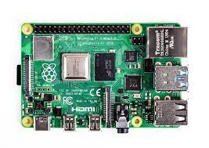Raspberry Pi is a series of small, single-board computers designed to be affordable, accessible, and versatile. These compact devices were created by the Raspberry Pi Foundation, a UK-based nonprofit organization, with the primary goal of promoting computer science education and enabling individuals to learn, experiment, and tinker with computing and electronics. Since its inception in 2012, the Raspberry Pi has gained widespread popularity, becoming a cornerstone in the world of DIY electronics, programming, and embedded systems.

The Raspberry Pi's hardware typically includes a CPU, RAM, USB ports, HDMI output, GPIO (General-Purpose Input/Output) pins, and various connectors for peripherals. While the hardware specifications have evolved over the years, the fundamental concept of affordability and accessibility has remained unchanged. Raspberry Pi devices are available at relatively low cost, making them accessible to students, hobbyists, and professionals alike.

One of the most significant advantages of the Raspberry Pi is its flexibility. Users can install a variety of operating systems, with the most common choice being a customized version of the Linux-based Raspbian (now known as Raspberry Pi OS). This operating system, combined with a rich ecosystem of software and programming languages, allows people to use Raspberry Pi for a wide range of applications, from basic web browsing and office tasks to more advanced projects like home automation, robotics, and media centers. Additionally, the GPIO pins enable users to interact with the physical world, making it a valuable tool for electronics enthusiasts.

Overall, Raspberry Pi has played a pivotal role in democratizing technology and fostering a vibrant community of enthusiasts, who share ideas, collaborate on projects, and push the boundaries of what's possible with these small but mighty computers. It continues to be a valuable resource for learning, prototyping, and creating innovative solutions in the world of computing and electronics.

**Features:**

Raspberry Pi devices are known for their versatile features, making them suitable for a wide range of applications. Here are some of the key features of Raspberry Pi:

* **Affordable:** Raspberry Pi boards are budget-friendly, making them accessible to a broad audience, including students, hobbyists, and professionals.
* **Compact Size:** These credit card-sized computers are highly portable, allowing for easy deployment in various scenarios.
* **Broad Hardware Options:** Raspberry Pi offers a variety of models with different hardware specifications to suit different needs, from entry-level to more powerful options.
* **GPIO Pins:** Each Raspberry Pi has a set of GPIO pins that allow users to interact with and control external hardware, such as sensors, motors, and LEDs, making it ideal for electronics projects.
* **Operating System Support:** Raspberry Pi supports a wide range of operating systems, with Raspberry Pi OS (formerly Raspbian) being the most popular. Users can also install various Linux distributions, Windows 10 IOT Core, and more.
* **Connectivity:** Raspberry Pi boards typically feature USB ports, Ethernet, HDMI output, audio output, and built-in wireless options (Wi-Fi and Bluetooth), providing multiple options for connecting peripherals and devices.
* **Software Ecosystem:** A rich software ecosystem is available for Raspberry Pi, including programming languages like Python, Java, and C/C++, as well as a vast library of pre-installed and downloadable software applications.
* **Community and Support:** Raspberry Pi has a large and active community of enthusiasts and developers who offer support, tutorials, and resources to help users get started and troubleshoots issues.
* **Educational Tool:** Raspberry Pi was originally designed for educational purposes, and it continues to serve as a valuable tool for learning computer science, programming, and electronics.
* **Versatile Applications:** Raspberry Pi can be used for a wide range of projects, including web servers, media centers, home automation systems, retro gaming consoles, robotics, IOT (Internet of Things) devices, and more.
* **Customization:** Users can modify and expand their Raspberry Pi setups through hardware add-ons called HATs (Hardware Attached on Top) and software customization, tailoring the device to their specific needs.
* **Low Power Consumption:** Raspberry Pi devices are energy-efficient, making them suitable for applications where power consumption is a concern.

These features, along with the continuously growing community and support, contribute to the enduring popularity and versatility of Raspberry Pi for various creative and technical projects.

**Raspberry pi Advanced Features:**

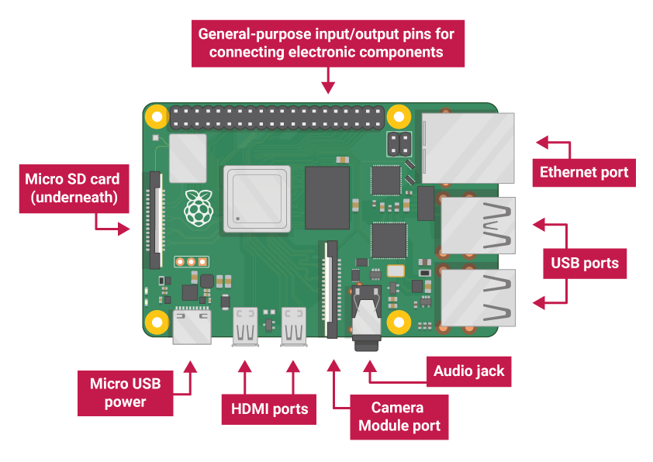

**Touch Module:**

A Raspberry Pi touch module, often referred to as a touchscreen display or a touch panel, is a peripheral device that can be connected to a Raspberry Pi single-board computer. These touch modules come in various sizes and types, and they are designed to provide a user-friendly interface for interacting with the Raspberry Pi. They typically consist of an LCD or OLED screen with touch-sensitive capabilities, allowing users to interact with the Raspberry Pi's graphical user interface (GUI) using their fingers or a stylus.

One of the key advantages of a Raspberry Pi touch module is its versatility. It can be used in a wide range of applications, from creating portable DIY tablets and kiosks to building interactive digital signage displays and embedded systems. The touch interface simplifies navigation and interaction with the Raspberry Pi, making it more accessible for users who may not be comfortable with traditional keyboard and mouse input.

To set up a Raspberry Pi touch module, you generally need to connect it to the Raspberry Pi's GPIO pins and configure the software to recognize and respond to touch input. Various operating systems and software solutions, like Raspbian (now Raspberry Pi OS), support touch input out of the box or with minimal configuration.

In summary, a Raspberry Pi touch module is a valuable addition to Raspberry Pi projects that require a user-friendly and interactive interface. It opens up numerous possibilities for creating customized, touch-enabled applications and systems, making it a popular choice for hobbyists, educators, and professionals working on a wide range of embedded computing projects.

**USB Ports:**

The Raspberry Pi single-board computer is equipped with USB (Universal Serial Bus) ports that serve various functions and are essential for connecting external devices and peripherals. These USB ports play a crucial role in expanding the functionality of the Raspberry Pi. Let's explore the USB ports of the Raspberry Pi in more detail.

The Raspberry Pi typically features multiple USB ports, with the exact number varying depending on the model. These USB ports are commonly used for connecting a wide array of peripherals such as keyboards, mice, external hard drives, Wi-Fi adapters, and other devices. The standard USB ports on the Raspberry Pi conform to USB 2.0 specifications, which offer decent data transfer rates for most common use cases. These ports are also known as USB Type-A ports and are rectangular in shape.

In addition to the standard USB 2.0 ports, some Raspberry Pi models, like the Raspberry Pi 4, feature USB 3.0 ports. USB 3.0, also referred to as Super Speed USB, offers significantly faster data transfer speeds compared to USB 2.0, making it suitable for high-bandwidth devices like external SSDs or HD webcams.

Users can connect USB devices to the Raspberry Pi by plugging them into these ports. The Raspberry Pi's operating system, like Raspberry Pi OS, is equipped with the necessary drivers to support a wide range of USB peripherals, making it easy to expand the capabilities of the computer with off-the-shelf devices. These ports are generally hot-swappable, meaning you can plug or unplug USB devices while the Raspberry Pi is running without causing any damage.

It's important to note that the total power consumption of all USB devices connected to the Raspberry Pi should not exceed the power supply's capacity. To ensure stable operation, it may be necessary to use a powered USB hub if you plan to connect multiple power-hungry devices.

In summary, the USB ports of the Raspberry Pi are essential for connecting various external devices and expanding the capabilities of the computer. They provide versatility and compatibility with a wide range of peripherals, making the Raspberry Pi a versatile platform for different projects and applications. Users should be aware of power considerations when connecting multiple USB devices to ensure proper operation.

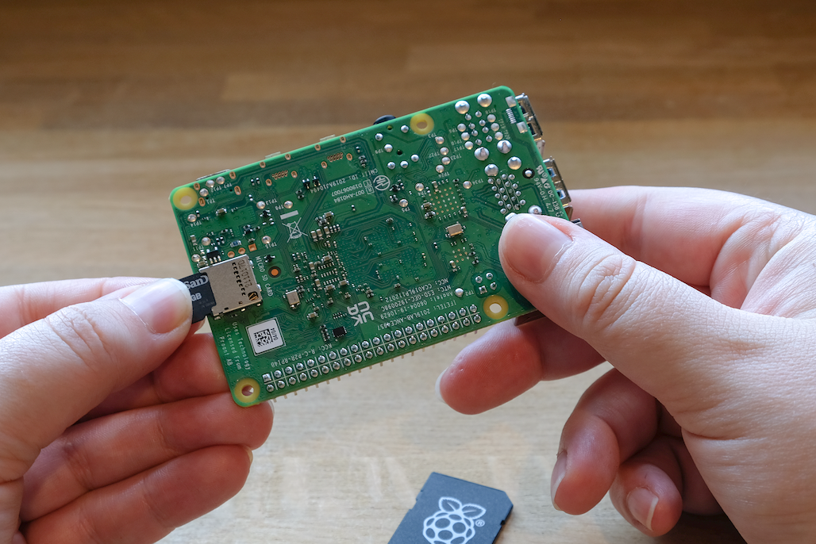**Micro SD Card Port:**

The micro SD card is a critical component of a Raspberry Pi single-board computer, serving as the primary storage medium for the operating system, applications, and user data. It is a small, removable flash memory card that slots into the Raspberry Pi, providing the necessary storage to boot the computer and run software.

When setting up a Raspberry Pi, you typically write an operating system image onto the micro SD card using a computer. This image contains the Raspberry Pi OS or any other compatible operating system. The micro SD card not only holds the OS but also acts as the primary storage for files, programs, and configurations. The card's capacity can vary, with higher-capacity cards allowing for more data storage.

One of the key advantages of using a micro SD card with the Raspberry Pi is its ease of use and portability. Users can easily swap out the micro SD card to switch between different operating systems or projects. However, it's important to choose a reliable and fast micro SD card, as the card's read and write speeds can significantly impact the Raspberry Pi's performance.

While micro SD cards are convenient, they have their limitations; including wear and tear over time due to constant read and writes operations, which may affect their lifespan. In some Raspberry Pi models, such as the Raspberry Pi 4, it is possible to boot from USB storage devices, which can provide increased durability and performance compared to micro SD cards.

In conclusion, the micro SD card is an integral part of the Raspberry Pi ecosystem, providing the essential storage medium for the operating system and data. It offers flexibility and easy project customization but requires careful consideration when selecting a reliable and adequately sized card to ensure the smooth operation of the Raspberry Pi.

**Ethernet port:**

The Ethernet port on a Raspberry Pi single-board computer is a vital component that enables a wired network connection. It typically features an RJ-45 connector and allows the Raspberry Pi to connect to a local network or the internet via an Ethernet cable. This wired connection provides a stable and high-speed network link, making it ideal for scenarios where a reliable and consistent network connection is essential.

One of the key advantages of using the Ethernet port on a Raspberry Pi is its reliability and consistent performance. It is particularly valuable for applications where a wireless (Wi-Fi) connection might be less stable or subject to interference. Ethernet connections are well-suited for tasks like serving as a web server, running network-attached storage (NAS), or participating in IOT (Internet of Things) projects that require constant connectivity.

To use the Ethernet port, you typically need to connect an Ethernet cable from the Raspberry Pi to a network switch, router, or a networked device like a computer. Most Raspberry Pi models come with a 10/100 Mbps Ethernet port, while the Raspberry Pi 4, for instance, features a Gigabit Ethernet port, offering significantly faster data transfer speeds.

While the Raspberry Pi can also connect to networks via Wi-Fi using a USB Wi-Fi adapter or onboard Wi-Fi (in some models), the Ethernet port remains an important and reliable option for network connectivity, especially in situations where a stable and high-speed connection is required.

In summary, the Ethernet port on a Raspberry Pi provides a dependable and high-speed network connection, making it an essential feature for various projects and applications where network stability and performance are critical. It offers an alternative to wireless connectivity and ensures that the Raspberry Pi can be seamlessly integrated into wired network environments.

**Usage of Raspberry pi:**

**Power Supply**

The following table shows the USB-PD power mode required to power various Raspberry Pi models. You can use any high quality power supply that provides the correct power mode.

| **Model** | **Recommended Power Supply (Voltage/Current)** | **Raspberry Pi Power Supply** |
| --- | --- | --- |
| Raspberry Pi 5 | 5V/5A, 5V/3A limits peripherals to 600mA | [27W USB-C Power Supply](https://www.raspberrypi.com/products/27w-usb-c-power-supply/) |
| Raspberry Pi 4 Model B | 5V/3A | [15W USB-C Power Supply](https://www.raspberrypi.com/products/type-c-power-supply/) |
| Raspberry Pi 3 (all models) | 5V/2.5A | [12.5W Micro USB Power Supply](https://www.raspberrypi.com/products/micro-usb-power-supply/) |
| Raspberry Pi 2 (all models) | 5V/2.5A | [12.5W Micro USB Power Supply](https://www.raspberrypi.com/products/micro-usb-power-supply/) |
| Raspberry Pi 1 (all models) | 5V/2.5A | [12.5W Micro USB Power Supply](https://www.raspberrypi.com/products/micro-usb-power-supply/) |
| Raspberry Pi Zero (all models) | 5V/2.5A | [12.5W Micro USB Power Supply](https://www.raspberrypi.com/products/micro-usb-power-supply/) |

Plug your power supply into the port marked "POWER IN", "PWR IN", or "PWR". Some Raspberry Pi models, such as the Zero series, have output USB ports with the same form factor as the power port. Be sure to use the correct port on your Raspberry Pi

**Boot Media**

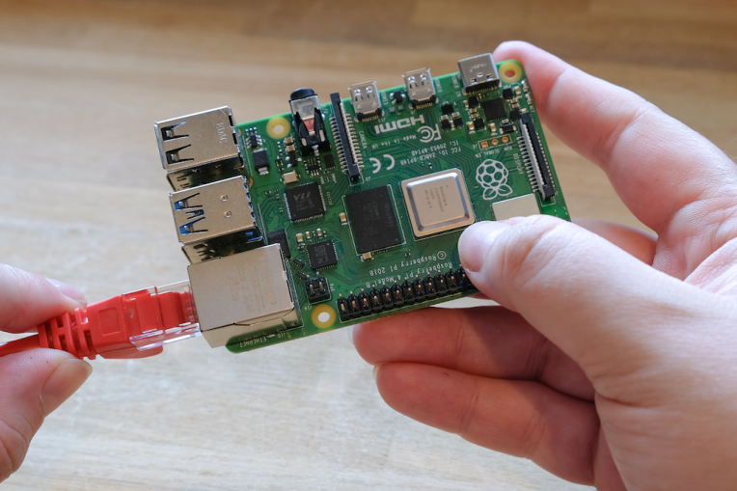Raspberry Pi models lack onboard storage, so you have to supply it. You can boot your Raspberry Pi from an operating system image installed on any supported media: commonly micro SD cards, but also USB storage, network storage, and storage connected via a PCI e HAT. However, only recent Raspberry Pi models support all of these media types.

All Raspberry Pi consumer models since the Raspberry Pi 1 Model A+ feature a micro SD slot. Your Raspberry Pi automatically boots from the micro SD slot when the slot contains a card.

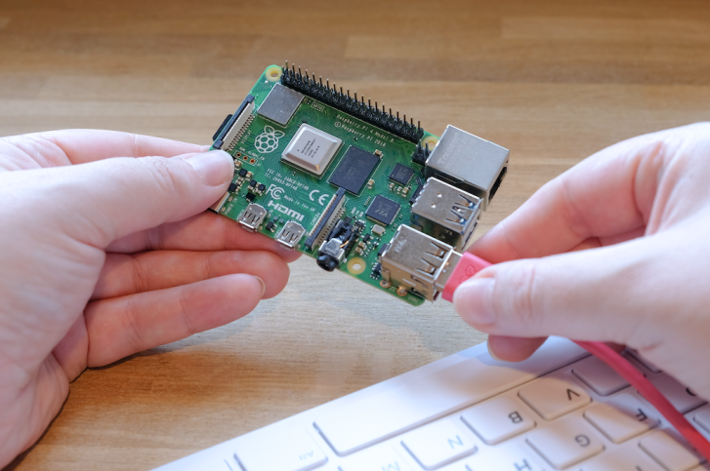

**Keyboard**

You can use any of the USB ports on your Raspberry Pi to connect a wired keyboard or USB Bluetooth receiver.

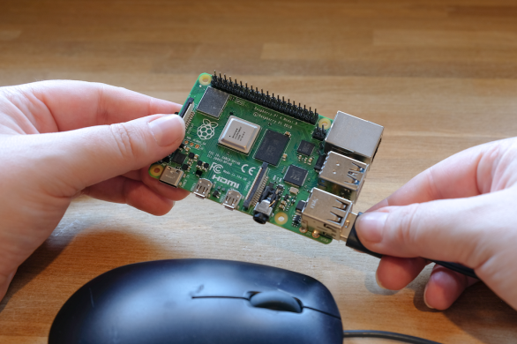**Mouse**

You can use any of the USB ports on your Raspberry Pi to connect a wired mouse or USB Bluetooth receiver.

**Audio**

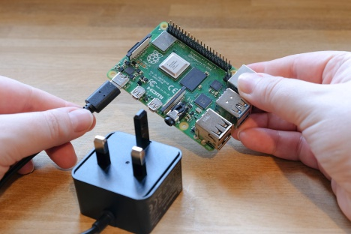All Raspberry Pi models with HDMI, micro HDMI, or mini HDMI support audio output over HDMI. All Raspberry Pi models support audio over USB. All Raspberry Pi models equipped with Bluetooth support Bluetooth audio. All variants of the Raspberry Pi 1, 2, 3, and 4 include a 3.5mm auxiliary TRRS jack which may require amplification for sufficient output volume.

**Networking**

The following Raspberry Pi models come with Wi-Fi and Bluetooth connectivity:

* Raspberry Pi 5
* Raspberry Pi 4
* Raspberry Pi 3B+
* Raspberry Pi 3
* Raspberry Pi Zero W
* Raspberry Pi Zero 2 W

The "Model B" suffix indicates variants with an Ethernet port; "Model A" indicates no Ethernet port. If your model doesn’t have an Ethernet port, you can still connect to a wired internet connection using a USB-to-Ethernet adapter.

**Pin out of Raspberry pi:**

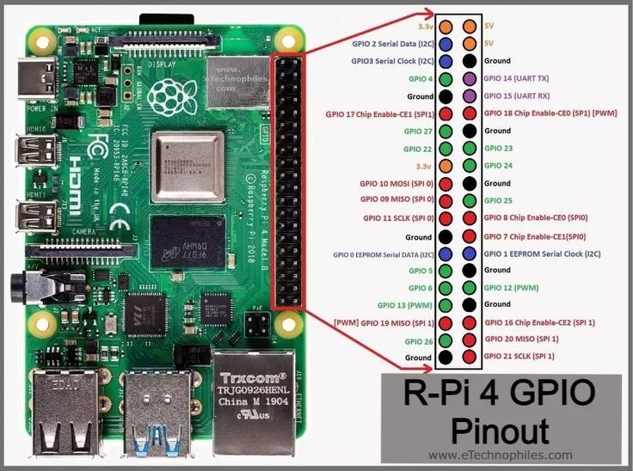

The Raspberry Pi GPIO (General-Purpose Input/Output) pins are essential for interfacing with various external hardware components and sensors. The pin out description can vary slightly depending on the specific Raspberry Pi model, as there have been different iterations of the board. Here, I'll provide an overview of the most common GPIO pin out for the Raspberry Pi Model B, but please note that you should always refer to the documentation specific to your Raspberry Pi model for precise pin descriptions.

Pin out for Raspberry Pi Model B (40-pin GPIO Header):

3.3V - Provides 3.3 volts of power for low-voltage components.

5V - Provides 5 volts of power for general use.

SDA - I2C data line for connecting to I2C devices.

5V - Provides 5 volts of power for general use.

SCL - I2C clock line for connecting to I2C devices.

GND - Ground (0V) connection.

GPIO 4 (GPCLK0) - General-purpose GPIO pin.

TXD - Transmit data for serial communication.

GND - Ground (0V) connection.

RXD - Receive data for serial communication.

GPIO 17 - General-purpose GPIO pin.

GPIO 18 (PCM_CLK) - General-purpose GPIO pin.

GPIO 27 - General-purpose GPIO pin.

GND - Ground (0V) connection.

GPIO 22 - General-purpose GPIO pin.

GPIO 23 - General-purpose GPIO pin.

3.3V - Provides 3.3 volts of power for low-voltage components.

GPIO 24 - General-purpose GPIO pin.

SPI MISO - SPI Master in Slave Out.

GND - Ground (0V) connection.

SPI MOSI - SPI Master Out Slave In.

GPIO 25 - General-purpose GPIO pin.

SPI SCLK - SPI Serial Clock.

SPI CE0 - SPI Chip Enable 0.

GND - Ground (0V) connection.

SPI CE1 - SPI Chip Enable 1.

ID_SD - I2C ID EEPROM (used to configure HATs).

ID_SC - I2C ID EEPROM (used to configure HATs).

GPIO 5 - General-purpose GPIO pin.

GND - Ground (0V) connection.

GPIO 6 - General-purpose GPIO pin.

GPIO 12 - General-purpose GPIO pin.

GPIO 13 - General-purpose GPIO pin.

GND - Ground (0V) connection.

GPIO 19 - General-purpose GPIO pin.

GPIO 16 - General-purpose GPIO pin.

GPIO 26 - General-purpose GPIO pin.

GPIO 20 - General-purpose GPIO pin.

GND - Ground (0V) connection.

GPIO 21 - General-purpose GPIO pin.

These pins allow you to connect and interface with a wide range of sensors, displays, and other hardware components, making the Raspberry Pi a versatile platform for various projects. Be sure to consult the documentation specific to your Raspberry Pi model to ensure accuracy.

**Why we need Raspberry pi:**

Raspberry Pi serves as a highly versatile and affordable single-board computer that has found applications in a multitude of domains, making it an indispensable tool for numerous purposes. First and foremost, it plays a pivotal role in education, offering an accessible platform for students and learners to dive into computer science, programming, and electronics. Its compact size and low cost democratize technology, allowing anyone to explore and experiment with computing concepts.

Beyond education, Raspberry Pi is the heart of a myriad of do-it-yourself (DIY) and hobbyist projects. Its GPIO pins enable users to interface with a wide range of sensors, motors, and other hardware components, making it ideal for building custom electronics, home automation systems, and robotics. It also finds use as a media center, capable of streaming and playing multimedia content, and as a retro gaming console through emulation software.

Moreover, Raspberry Pi is an excellent choice for Internet of Things (IOT) development, facilitating the creation of connected devices and smart solutions. It can serve as a low-power, always-on server for hosting web applications, controlling remote systems, or managing data. With the support of a vast software ecosystem, it is adaptable to diverse needs and use cases, from basic web browsing and office tasks to complex data analysis and machine learning.

In summary, Raspberry Pi is a versatile and cost-effective computing platform that has empowered individuals, students, and professionals to innovate, learn, and bring their creative ideas to life. Its small form factor, affordability, and extensive community support have made it an indispensable tool for fostering innovation and technological exploration across a wide spectrum of applications.

**Specifications:**

The specifications of a Raspberry Pi can vary depending on the specific model. However, here are the general specifications of the Raspberry Pi 4 Model B, one of the most popular and feature-rich Raspberry Pi models as of my knowledge cutoff date in 2022:

* **CPU:** Quad-core ARM Cortex-A72 processor (64-bit)
* **GPU:** Video Core VI graphics processing unit
* **RAM:** 2GB, 4GB, or 8GB LPDDR4-3200 SDRAM (RAM capacity depends on the model)
* **Storage:** micro SD card slot for storage
* **Connectivity:**
* 2 × USB 3.0 ports
* 2 × USB 2.0 ports
* 2 × micro HDMI ports (supporting up to 4K displays)
* Gigabit Ethernet port
* Dual-band 802.11ac wireless LAN (Wi-Fi)
* Bluetooth 5.0
* **GPIO Pins:** 40-pin GPIO header for interfacing with external hardware
* **Audio:** 3.5mm audio jack, as well as HDMI audio output
* **Video:** H.265 (4Kp60 decode), H.264 (1080p60 decode, 1080p30 encode)
* **Power:** 5V/3A via USB-C connector
* **Operating System:** Supports various operating systems, including Raspberry Pi OS, Linux distributions, and more.

Please note that newer Raspberry Pi models may have different specifications, and the Raspberry Pi Foundation regularly releases updated versions with improved features and capabilities. Therefore, it's advisable to check the specifications of the specific Raspberry Pi model you are using or considering for your project.

**Applications:**

Raspberry Pi has a wide range of applications across various fields and industries. Its versatility and affordability make it a popular choice for numerous projects. Here are some common applications of Raspberry Pi:

* **Education:** Raspberry Pi was initially created to promote computer science education. It is widely used in schools and educational institutions to teach programming, electronics, and general computing concepts.
* **DIY Electronics:** Raspberry Pi is a favorite among hobbyists and tinkerers for creating custom electronics projects. Its GPIO pins allow users to interface with sensors, motors, and other components, enabling the development of innovative gadgets.
* **Home Automation:** Raspberry Pi can be used to create home automation systems. You can build smart home solutions to control lights, thermostats, and security cameras, making your home more efficient and secure.
* **Media Center:** With the help of media center software like Kodi or Plex, Raspberry Pi can turn your TV into a smart media hub. You can stream movies, music, and videos from the internet or a local network.
* **Retro Gaming:** Raspberry Pi can emulate classic gaming consoles like NES, SNES, and more. It's a popular choice for retro gaming enthusiasts who want to play vintage games on a modern display.
* **Internet of Things (IOT):** Raspberry Pi is ideal for IOT projects. You can create connected devices to monitor and control various aspects of your environment, from weather stations to smart doorbells.
* **Server:** It can function as a lightweight server for hosting websites, blogs, or file-sharing services. Raspberry Pi is energy-efficient and suitable for low-traffic websites and local network services.
* **Robotics:** Raspberry Pi can serve as the brains of a robot, controlling its movements and sensors. It's commonly used in educational robotics and hobbyist projects.
* **Network Attached Storage (NAS):** By connecting external hard drives or USB storage devices, you can turn your Raspberry Pi into a low-cost NAS server for data storage and backup.
* **Security Cameras:** Raspberry Pi can be used to build a home security system with multiple cameras, recording video and providing remote access to live feeds.
* **Art and Creative Projects:** Artists and creators use Raspberry Pi for interactive art installations, digital art, and multimedia projects, thanks to its compact size and capabilities.
* **Environmental Monitoring:** Raspberry Pi can be employed for environmental monitoring, collecting data on temperature, humidity, air quality, and more.
* **Weather Stations:** You can build your own weather station with sensors and cameras, and the Raspberry Pi can process and display the data.
* **Remote Control and Automation:** Raspberry Pi can be used to automate and control various devices and systems, from irrigation systems to home theaters.
* **Voice Assistants:** With the right software and microphone setup, you can create your own voice-activated assistant, similar to Siri or Alexa.

**Description:**

Raspberry Pi, often abbreviated as "RasPi," is a series of compact single-board computers designed to be an affordable, accessible, and versatile computing platform. Created by the Raspberry Pi Foundation, a UK-based nonprofit organization, the primary objective behind Raspberry Pi is to promote computer science education and provide individuals of all ages with a platform to learn, experiment, and tinker with computing and electronics. Since its introduction in 2012, Raspberry Pi has evolved into a highly popular and influential technology platform with a dedicated and enthusiastic user community.

At its core, Raspberry Pi is a credit card-sized computer featuring essential components such as a central processing unit (CPU), RAM, USB ports, HDMI output, a micro SD card slot for storage, and a GPIO (General-Purpose Input/Output) header. These components have evolved and improved across various Raspberry Pi models, but the foundational principles of affordability and accessibility remain constant. This affordability has been instrumental in making computing education and experimentation accessible to a broader audience, including students, hobbyists, and professionals.

One of the distinguishing features of Raspberry Pi is its versatility. Users can install a variety of operating systems on the device, with Raspberry Pi OS (formerly known as Raspbian) being the most common choice. This operating system, coupled with a diverse software ecosystem and support for multiple programming languages, allows individuals to employ Raspberry Pi for a multitude of applications. From basic web browsing and office tasks to more advanced projects, such as home automation, robotics, and media centers, Raspberry Pi offers a wide array of possibilities.

The GPIO pins on the Raspberry Pi are a crucial component. They enable users to interact with the physical world by connecting to external hardware and sensors, making the Raspberry Pi an invaluable tool for electronics enthusiasts. This feature allows for creative and educational projects, such as building custom electronic gadgets, robots, and IOT (Internet of Things) devices.

In summary, Raspberry Pi has played a pivotal role in democratizing technology, fostering creativity, and facilitating educational initiatives. Its impact spans across a diverse spectrum of fields, from education and DIY electronics to IOT development and more. The Raspberry Pi community, which is characterized by collaboration and the sharing of ideas and projects, continues to drive innovation and exploration in the world of computing and electronics, ensuring that Raspberry Pi remains at the forefront of technology education and experimentation